1. **ReactJS-HOL**

**1. Define SPA and its benefits**

SPA (Single Page Application) is a web application or website that interacts with the user by dynamically rewriting the current page rather than loading entire new pages from the server. This approach makes the application faster and provides a smoother user experience.

Benefits of SPA:

* Faster Navigation: No need to reload the whole page.
* Improved User Experience: Feels more like a desktop application.
* Less Server Load: Only data is exchanged, not full pages.
* Easier Debugging: Most SPAs use browser developer tools effectively.

**2. Define React and identify its working**

React is an open-source JavaScript library developed by Facebook for building user interfaces, especially for single-page applications. It allows developers to create large web applications that can update and render efficiently with changing data.

How React works:

* React uses components, which are reusable pieces of UI.
* It creates a virtual DOM (a copy of the real DOM) and updates only the parts that change.
* React follows a unidirectional data flow, making the code easier to understand and debug.

**3. Identify the differences between SPA and MPA**

| Feature | SPA (Single Page Application) | MPA (Multi Page Application) |
| --- | --- | --- |
| Page Load | Loads once and updates dynamically | Loads a new page for each request |
| Speed | Faster after initial load | Slower due to full-page reloads |
| Development | Mostly uses JavaScript frameworks | Often uses server-side rendering |
| Navigation | Uses JavaScript routing | Traditional server-side routing |
| SEO | Harder to optimize | Easier to manage |

**4. Explain Pros & Cons of Single-Page Application**

Pros:

* Fast and responsive experience
* Reduces server traffic
* Easier to develop and test once structure is set
* Better caching possibilities

Cons:

* SEO optimization is harder
* May have slower initial loading time
* Can be complex for large apps
* JavaScript must be enabled in the browser

**5. Explain about React**

React is a component-based JavaScript library used to build interactive user interfaces. It helps in building reusable UI components, manages the application's view layer, and efficiently updates the UI when the data changes. It supports both client-side and server-side rendering and is widely used for developing SPAs.

**6. Define Virtual DOM**

The Virtual DOM is a lightweight copy of the actual DOM used by React. Whenever the application state changes, React creates a new virtual DOM and compares it with the previous one using a process called diffing. It then updates only the changed elements in the real DOM. This makes the application faster and more efficient.

**7. Explain Features of React**

* Component-Based Architecture: UI is divided into reusable components.
* Virtual DOM: Speeds up rendering and improves performance.
* JSX Syntax: Allows writing HTML inside JavaScript.
* One-Way Data Binding: Makes data flow predictable.
* Declarative UI: Easy to design interactive interfaces.
* Strong Community Support: React has a large and active community.
* Fast Rendering: Only the necessary parts of the UI are re-rendered.

**Code:**  
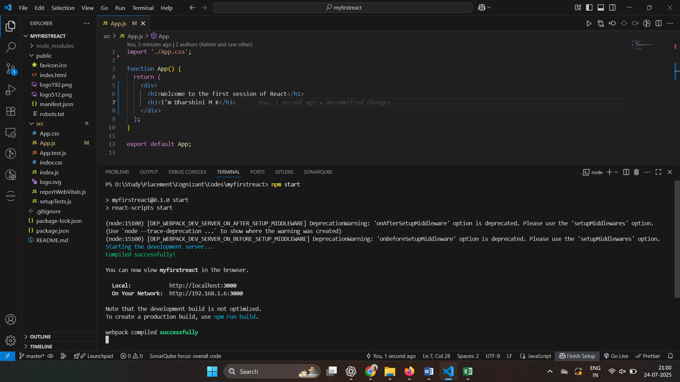

**Output:**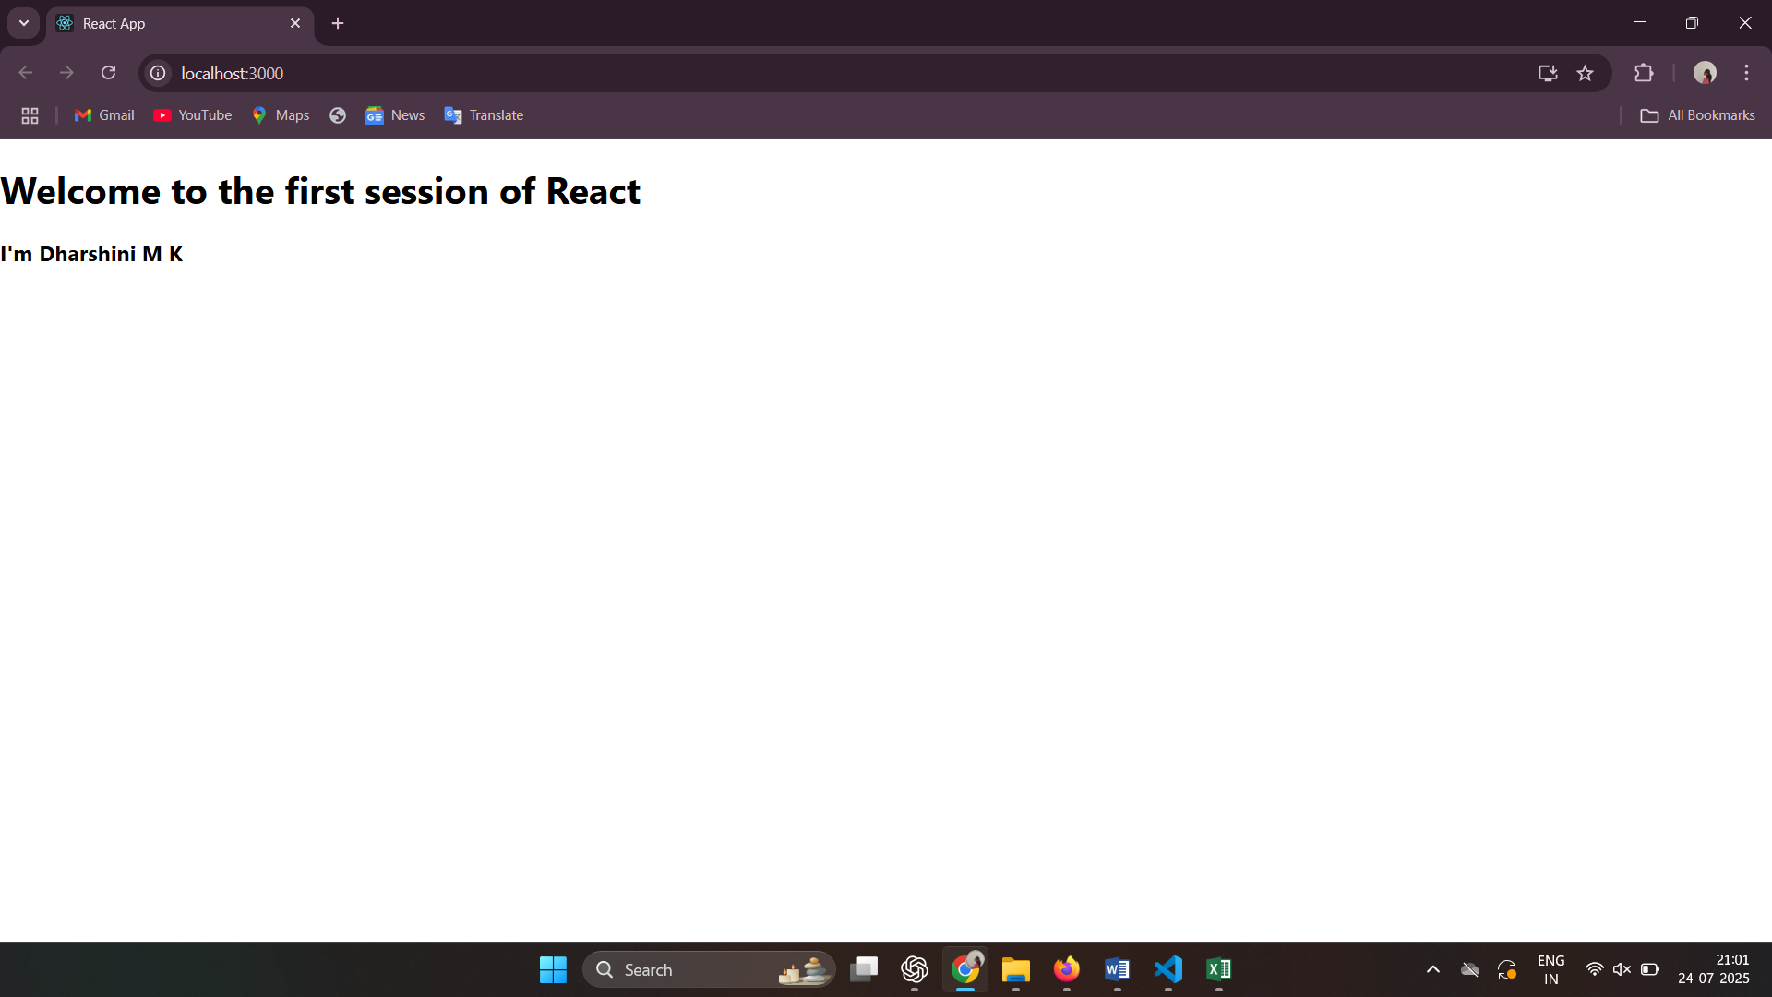

1. **ReactJS-HOL**

**1. Explain React Components**

React components are the building blocks of any React application. They are independent, reusable pieces of UI that return elements to be displayed on the screen. Components allow developers to break down the user interface into smaller, manageable parts.

**2. Identify the Differences Between Components and JavaScript Functions**

| Feature | React Components | JavaScript Functions |
| --- | --- | --- |
| Purpose | Used to create UI elements | Used to perform logic or operations |
| Return Type | Returns JSX (HTML-like code) | Returns values or executes logic |
| Reusability | Designed to be reused in UI | May or may not be reused |
| Lifecycle Methods | Have access to React lifecycle (class) | No built-in lifecycle methods |
| State Management | Can manage state (class/function with hooks) | Cannot manage state on their own |

**3. Identify the Types of Components**

React has mainly two types of components:

1. Class Components – Components that are ES6 classes and extend React.Component.
2. Function Components – Simple JavaScript functions that return JSX.

**4. Explain Class Component**

A Class Component is a type of React component defined using a JavaScript class that extends React.Component. It can hold its own state and use lifecycle methods such as componentDidMount, componentDidUpdate, etc.

*class Home extends Component {*

*render() {*

*return (*

*<div>*

*<h3>Welcome to the Home page of Student Management portal</h3>*

*</div>*

*);*

*}*

*}*

**5. Explain Function Component**

A Function Component is a simpler way to write components. It is a regular JavaScript function that takes props as an argument and returns JSX. With the introduction of Hooks, function components can also manage state and side effects.

*function App() {*

*return (*

*<div className="container">*

*<Home />*

*<About />*

*<Contact />*

*</div>*

*);*

*}*

**6. Define Component Constructor**

In class components, the constructor() is a special method used to initialize state and bind methods. It is called before the component is mounted.

*constructor(props) {*

*super(props);*

*this.state = { name: "React" };*

*}*

**7. Define render() Function**

The render() function is a required method in class components. It describes what should be displayed on the screen. It returns the JSX code to be rendered in the browser.

*render() {*

*return (*

*<div>*

*<h3>Welcome to the Home page of Student Management portal</h3>*

*</div>*

*); } }*

**Code:**

App.js:

import './App.css';

import Home from './Components/Home';

import About from './Components/About';

import Contact from './Components/Contact';

function App() {

  return (

    <div className="container">

      <Home />

      <About />

      <Contact />

    </div>

  );

}

export default App;

Home.js:

import React, { Component } from 'react';

class Home extends Component {

  render() {

    return (

      <div>

        <h3>Welcome to the Home page of Student Management portal</h3>

      </div>

    );

  }

}

export default Home;

About.js:

import React, { Component } from 'react';

class About extends Component {

  render() {

    return (

      <div>

        <h3>Welcome to the About page of Student Management portal</h3>

      </div>

    );

  }

}

export default About;

Contact.js:

import React, { Component } from 'react';

class Contact extends Component {

  render() {

    return (

      <div>

        <h3>Welcome to the Contact page of Student Management portal</h3>

      </div>

    );

  }

}

export default Contact;

**Output:**  
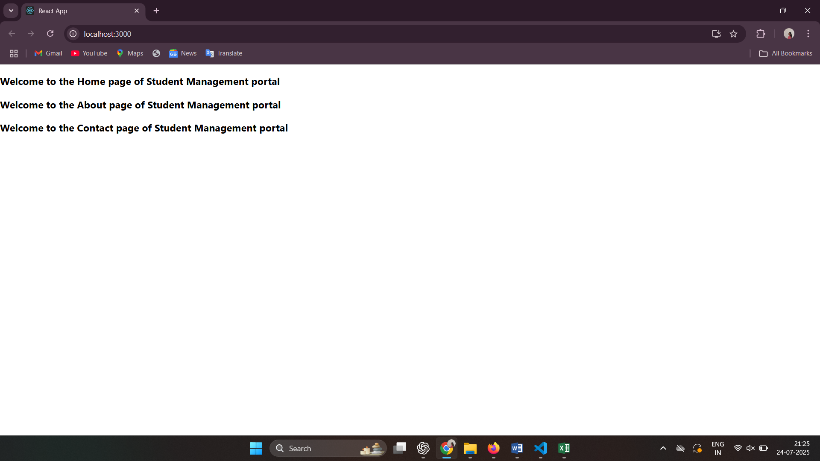

1. **ReactJS-HOL**

**Code:**

App.js:

import { CalculateScore } from '../src/Components/CalculateScore';

function App() {

  return (

    <div>

      <CalculateScore

        Name={"Dharshini M K"}

        School={"SSM Lakshmi Ammal Matriculation Higher Secondary School"}

        total={567}

        goal={6}

      />

    </div>

  )

}

export default App;

CalculateScore.js:

import '../Stylesheets/mystyle.css';

const percentToDecimal = (decimal) => {

    return (decimal.toFixed(2) + '%')

}

const calcScore = (total, goal) => {

    return percentToDecimal(total/goal)

}

export const CalculateScore = ({ Name, School, total, goal }) => (

    <div className="formatstyle">

        <h1><font color="Brown">Student Details:</font></h1>

        <div className="Name">

            <b><span> Name: </span> </b>

            <span>{Name}</span>

        </div>

        <div className="School">

            <b><span> School: </span> </b>

            <span>{School}</span>

        </div>

        <div className="Total">

            <b><span>Total:</span> </b>

            <span>{total}</span>

            <span>Marks</span>

        </div>

        <div className="Score">

            <b>Score:</b>

            <span>

                {calcScore(

                    total,

                    goal

                )}

            </span>

        </div>

    </div>

)

mystyle.css:

.Name {

    font-weight: 300;

    color: blue;

}

.School {

    color: crimson;

}

.Total {

    color: darkmagenta;

}

.formatstyle {

    text-align: center;

    font-size: large;

}

.Score {

    color: forestgreen;

}

**Output:**  
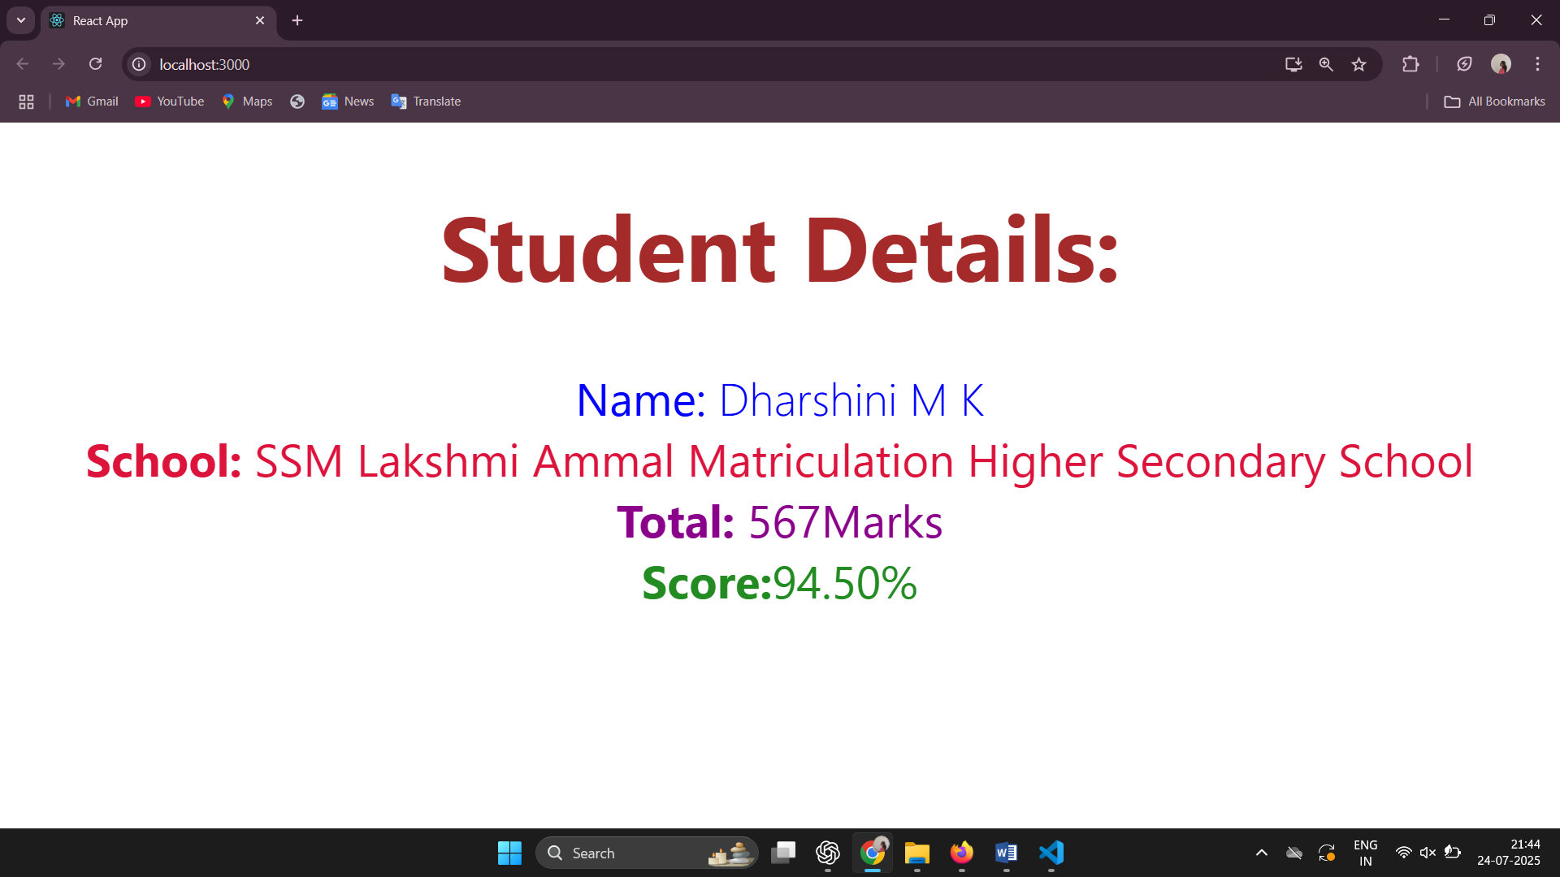

1. **ReactJS-HOL**

**1. Explain the Need and Benefits of Component Life Cycle**

The component lifecycle in React defines the series of phases a component goes through from creation to removal. Understanding this lifecycle helps developers control what happens at different stages of a component’s existence.

Need for Component Lifecycle:

* To perform specific actions at different stages (e.g., fetching data after rendering).
* To manage side effects like API calls, event listeners, or DOM manipulations.
* To handle performance optimization and resource cleanup.

Benefits:

* Better control over behavior: Helps manage state and props during updates.
* Efficient resource management: Cleanup prevents memory leaks.
* Improved performance: Optimize re-rendering using lifecycle methods.
* Ease in debugging: Lifecycle hooks help track the component’s flow.

**2. Identify Various Lifecycle Hook Methods**

React class components have lifecycle methods grouped into three main phases:

1. Mounting (component is being added to the DOM):

* constructor()
* static getDerivedStateFromProps()
* render()
* componentDidMount()

2. Updating (component is being re-rendered due to state/prop change):

* static getDerivedStateFromProps()
* shouldComponentUpdate()
* render()
* getSnapshotBeforeUpdate()
* componentDidUpdate()

3. Unmounting (component is being removed from the DOM):

* componentWillUnmount()

**3. List the Sequence of Steps in Rendering a Component**

Here’s the sequence of steps when a class component is rendered (Mounting phase):

1. constructor() – Initializes state and binds methods.
2. getDerivedStateFromProps() – Updates state from props before rendering.
3. render() – Returns JSX to be displayed.
4. componentDidMount() – Called after the component is rendered to the DOM.

If the component updates (due to props/state changes), the following sequence occurs:

1. getDerivedStateFromProps()
2. shouldComponentUpdate()
3. render()
4. getSnapshotBeforeUpdate()
5. componentDidUpdate()

When the component is removed:

* componentWillUnmount() is called for cleanup.

**Code:**

App.js:

import React from 'react';

import Posts from './Posts';

function App() {

  return (

    <div className="App">

      <Posts />

    </div>

  );

}

export default App;

Post.js:

class Post {

    constructor (id, title, body)

    {

        this.id=id;

        this.title=title;

        this.body=body;

    }

}

export default Post;

Posts.js:

import React, { Component } from 'react';

import Post from './Post';

class Posts extends Component {

  constructor(props) {

    super(props);

    this.state = {

      posts: [],

    };

  }

  // Step 6: loadPosts method

  loadPosts = () => {

    fetch('https://jsonplaceholder.typicode.com/posts')

      .then(response => response.json())

      .then(data => {

        const posts = data.map(p => new Post(p.userId, p.id, p.title, p.body));

        this.setState({ posts });

      })

      .catch(error => {

        console.error("Error fetching posts:", error);

        alert("Error loading posts");

      });

  };

  // Step 7: componentDidMount

  componentDidMount() {

    this.loadPosts();

  }

  // Step 9: Error handling

  componentDidCatch(error, info) {

    alert("Something went wrong! 🫠");

    console.log("Error caught:", error, info);

  }

  // Step 8: Render Method

  render() {

  return (

    <div style={{ padding: '20px', fontFamily: 'Arial' }}>

      <h2 style={{ textAlign: 'center', color: '#333' }}>📚 Blog Posts</h2>

      <div style={{ display: 'flex', flexDirection: 'column', gap: '20px' }}>

        {this.state.posts.map(post => (

          <div key={post.id} style={{

            border: '1px solid #ccc',

            padding: '15px',

            borderRadius: '10px',

            boxShadow: '2px 2px 8px rgba(0, 0, 0, 0.1)',

            backgroundColor: '#f9f9f9'

          }}>

            <h3 style={{ color: '#2a2a2a', marginBottom: '10px' }}>

              {post.id}. {post.title}

            </h3>

            <p style={{ color: '#555' }}>{post.body}</p>

          </div>

        ))}

      </div>

    </div>

  );

}

}

export default Posts;

**Output:**

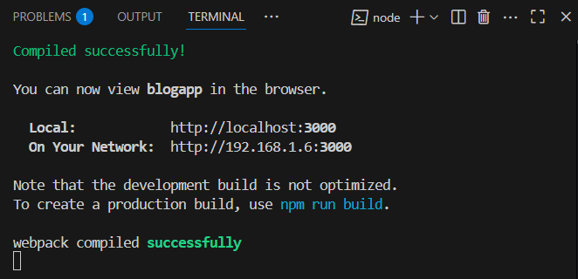

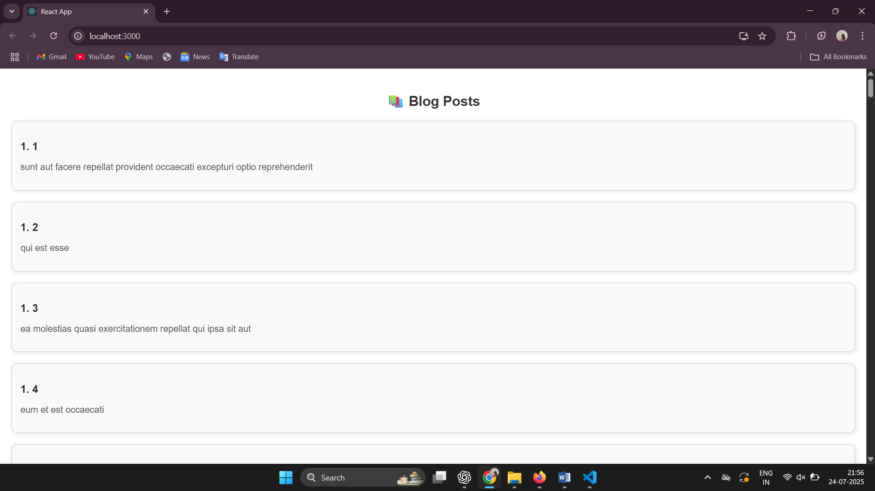

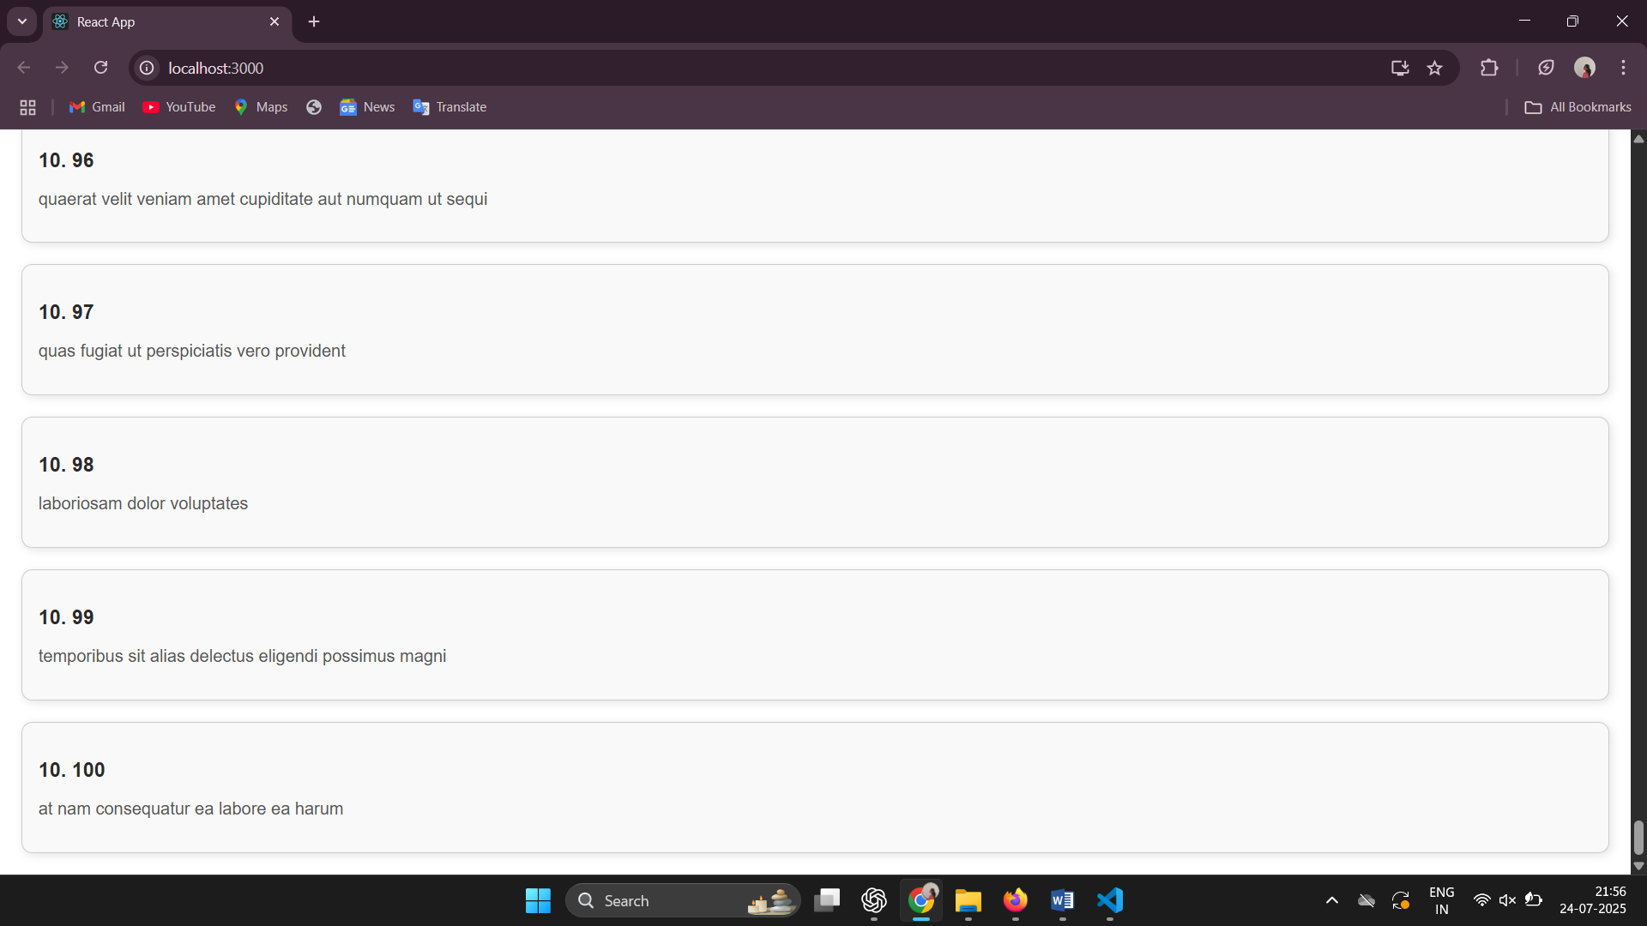

1. **ReactJS-HOL**

**Code:**

CohortDetails.js:

import styles from './CohortDetails.module.css';

function CohortDetails(props) {

    const headingStyle = {

        color: props.cohort.currentStatus === 'ongoing' ? 'green' : 'blue'

    };

    return (

        <div className={styles.box}>

            <h3 style={headingStyle}>

                {props.cohort.cohortCode} -

                <span>{props.cohort.technology}</span>

            </h3>

            <dl>

                <dt>Started On</dt>

                <dd>{props.cohort.startDate}</dd>

                <dt>Current Status</dt>

                <dd>{props.cohort.currentStatus}</dd>

                <dt>Coach</dt>

                <dd>{props.cohort.coachName}</dd>

                <dt>Trainer</dt>

                <dd>{props.cohort.trainerName}</dd>

            </dl>

        </div>

    );

}

export default CohortDetails;

CohortDetails.module.css:

.box {

  width: 300px;

  display: inline-block;

  margin: 10px;

  padding: 10px 20px;

  border: 1px solid black;

  border-radius: 10px;

}

dt {

  font-weight: 500;

}

**Output:**

